- Problem Statement
In the real world, trip planning is:
- Fragmented and manual
- Users search destinations on one app
- Book routes on another
- Find stays somewhere else
- No system understands user travel intent holistically
Core Problem:
- Human travel preferences are unstructured
- Systems require structured data
- No intelligent system converts intent → structured itinerary automatically

- What is Safar AI? (Solution)
Safar AI is a Generative AI-driven trip planning system that:
- Understands user intent (inputs)
- Reasons over constraints (budget, time, preferences)
- Generates personalized & structured itineraries
- Enhances AI output using real-time external data
- Behaves like an AI travel consultant (not a static booking app)

- Frontend Layer (Technologies Used)

HTML
- Structures the web pages
- Creates forms for user travel inputs
- Defines layout of itinerary display
CSS
- Styles the UI
- Makes the interface responsive
- Improves user experience
JavaScript
- Handles user interactions
- Sends API requests to backend (Fetch API / AJAX)
- Dynamically updates itinerary without reloading page
- Performs client-side validation

- Backend / API Layer (Middleman)

Python
- Core backend programming language
- Handles business logic
- Processes user travel constraints
FastAPI
- High-performance Python web framework
- Creates RESTful APIs
- Automatically generates API documentation (Swagger UI)
- Handles request validation using Pydantic models
- Asynchronous support for fast response

- Database Layer (Cloud)

MongoDB Atlas
It is used in Safar AI to:
- Store user data
- Save travel history
- Save generated itineraries
- Enable personalization for future trips

- AI / Generative Layer
- LLM APIs → Gemini
- Prompt Engineering
  - Better input → better output
- Context Injection
  - Add user preferences
- If input bad → output bad

- External Intelligence Layer
- Google Maps API
- OpenRoute API
Used for:
- Distance calculation
- Route optimization
- Location validation

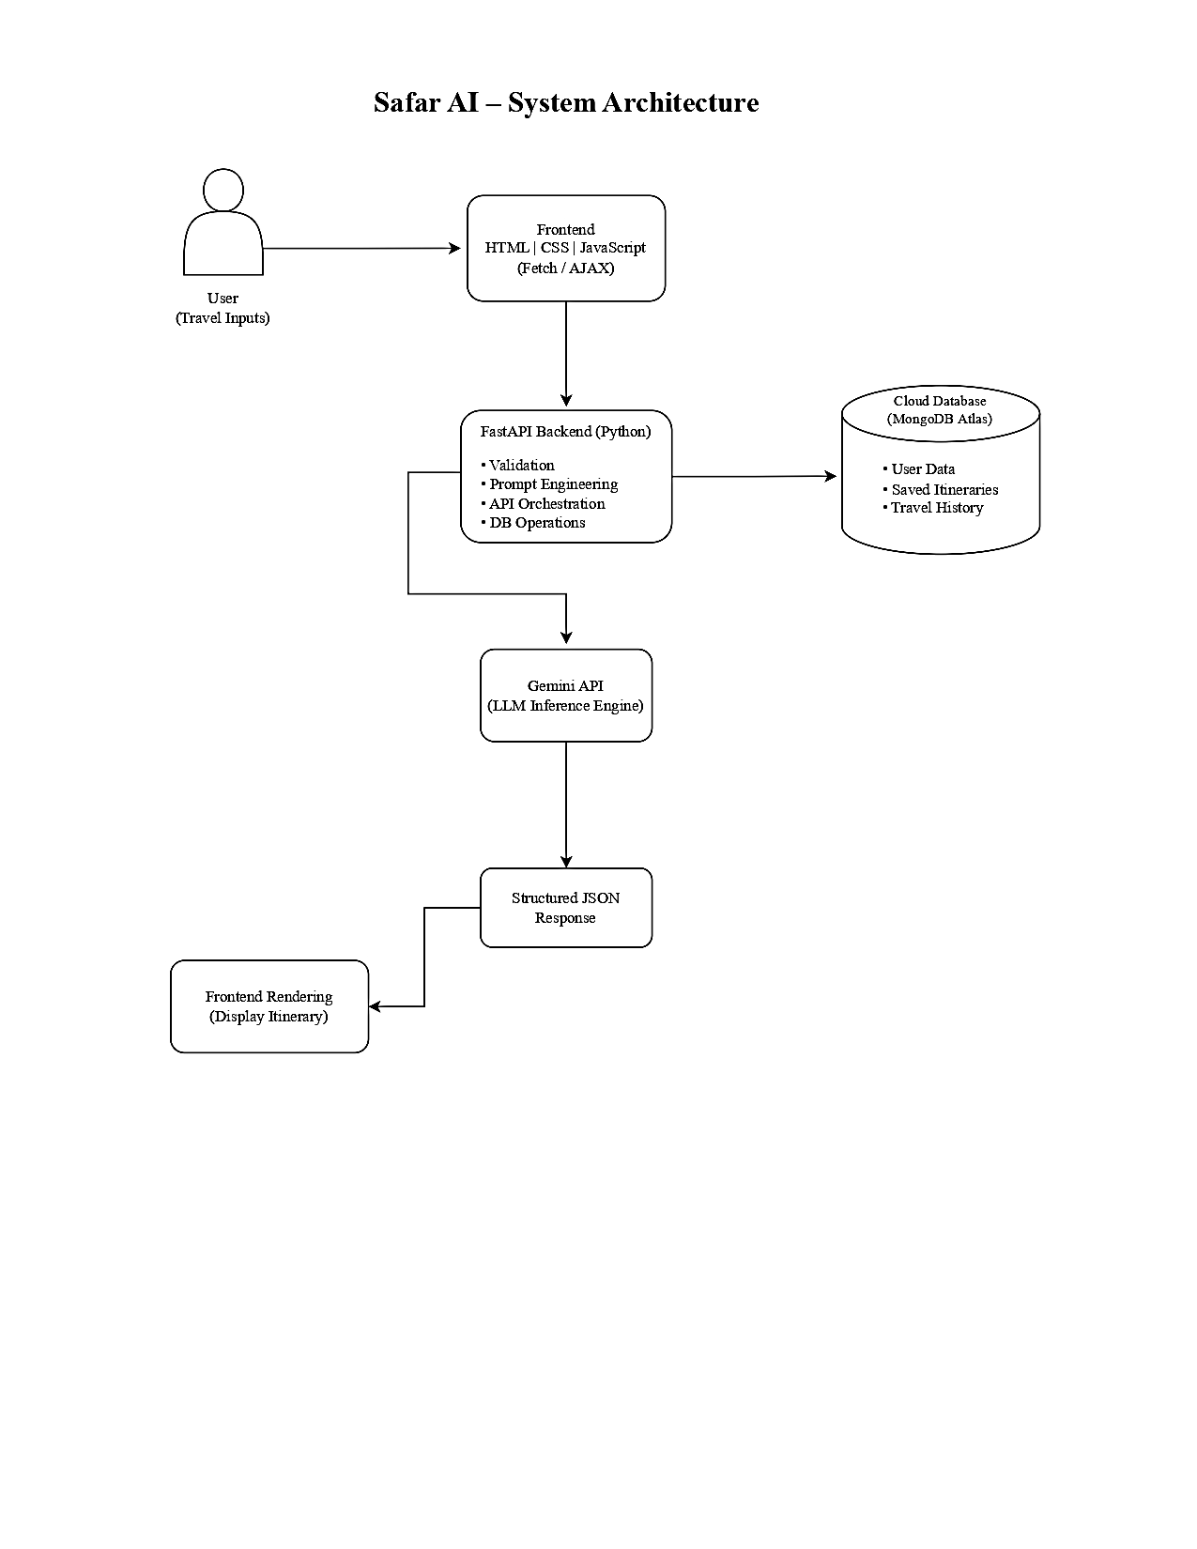
- System Architecture (WorkFlow)

